LABORATORY TECHNICAL REPORT: DIGITAL ACTUATION AND ANALOG SENSOR SIGNAL CONDITIONING VIA VIRTUAL INSTRUMENTATION
Course Code: EE034-4-2-SNA

1. INTRODUCTION & THEORETICAL FRAMEWORK

1.1 Digital Actuation and Electroluminescence Principles
Modern industrial automation relies on a combination of discrete digital control channels and continuous analog instrumentation loops. Digital actuation operates exclusively on binary states: a logic high level (1, typically corresponding to +5 V or +3.3 V DC) or a logic low level (0, indicating system ground, 0 V).
In this laboratory work, solid-state Light Emitting Diodes (LEDs) serve as digital actuators. An LED is a forward-biased p–n junction semiconductor diode that operates on the principle of electroluminescence. When a forward bias voltage exceeding the material's threshold voltage (Vd≈1.8 VV to V2.2V for standard red/green indicators) is applied, minority carriers are injected across the depletion region. Electrons from the conduction band recombine with holes in the valence band, releasing energy in the form of photons.
To protect the internal digital output circuit of the Data Acquisition (DAQ) controller from drawing excessive current, a series current-limiting resistor (RlimitR_{limit}Rlimit​) is mandatory. Using Ohm’s Law, the resistor value is selected based on the desired forward drive current (I_{f}≈10mA toA20mA):
$$Rlimit​=\frac{VDAQ​-Vd}{If​​}$$
This equation ensures that the LED operates within its safe current range while maintaining stable illumination and preventing damage to both the LED and the DAQ output circuitry.

1.2 Operational Physics of NTC Thermistors
A Negative Temperature Coefficient (NTC) thermistor is a thermally sensitive ceramic semiconductor component whose electrical resistance decreases non-linearly as temperature increases. This behavior is governed by charge carrier dynamics within the semiconductor material. As thermal energy ((k _{B T})) is introduced into the system, electrons are thermally excited across the bandgap ((E _{g})) from the valence band to the conduction band. The carrier concentration ((n)) increases exponentially with temperature according to the relation:
$$n\left(T\right)∝\exp\left(-\frac{2kB​T}{Eg​​}\right)$$
where (k _{B}) is the Boltzmann constant and (T) is the absolute temperature in Kelvin. Since electrical conductivity is directly proportional to charge carrier concentration, an exponential increase in carrier density results in a significant and non-linear reduction in the bulk resistance of the thermistor (R _{ntc} ).

1.3 Mathematical Formulation of the Low-Side Voltage Divider Circuit Model
Because an Analog-to-Digital Converter (ADC) cannot directly read resistance, a signal conditioning circuit must transform resistance variations into a measurable voltage signal. This is achieved via a series voltage divider network excited by a stable DC voltage reference V_{_{in}} = 5.0 V)):
$$Vout​=Vin​(\frac{Rntc}{R1​+Rntc​​​})$$

To reconstruct the underlying sensor state in software, the unknown variable (R _{ntc}) must be isolated as an explicit function of (V_{in}}), (V _{out}), and the fixed pull-up resistor R1​=10,000Ω Cross-multiplying the voltage divider relation yields:

$$Vout​R1​+Vout​Rntc​=Vin​Rntc​$$
$$V_{\left\{out\right\}R_{1}}=R_{\left\{ntc\right\} \left(V_{\left\{in\right\}}-V_{\left\{out\right\}}\right)} \\ Rntc​=\frac{​\left(R1\right)}{\left(Vin​-Vout​Vout\right)​​​}$$

1.4 Thermodynamic Calibration Modeling via the Beta (B) Parameter Equation
To map calculated non-linear resistance profiles back to absolute temperatures, the simplified exponential Beta (B) parameter equation is implemented:

$$Rntc​\left(T\right)=Rr​⋅\exp\left[B\left(\left(\frac{1}{Tcalc}​\right)​-\left(\frac{1}{Tr}\right)​​\right)\right]$$

where R _{r} is the nominal sensor resistance evaluated at a standard calibration reference temperature ($T _{r} = 298.15 K, equivalent to (25∘C) Solving this expression algebraically for absolute target temperature (T__{{calc}) by taking the natural logarithm (ln) of both sides establishes the core mathematical calibration algorithm used by the DAQ system:
$$Tcalc​ = {\left[\left(\frac{1}{Tr​}\right)​+\left(\frac{1}{B}\right)​\ln\left(\frac{Rntc}{Rr​​}\right)\right]}^{-1}$$

2. SYSTEM SETUP, INSTRUMENTATION, & HARDWARE CIRCUITRY

2.1 Hardware Components and Wiring Specifications
The hardware configuration is systematically constructed on a solderless breadboard to interface input and output channels through a National Instruments Data Acquisition (NI-DAQ) platform.
- Task 1 (Single LED Control): A single digital output channel line from the DAQ module connects directly to the anode of a standard LED. A 330Ω resistor is placed in series with the cathode to limit current draw on the channel.
- Task 2 (Multiple Sequential LEDs): Three independent digital output channels from the DAQ module are mapped to three separate LEDs on the breadboard. Each individual LED path contains its own 330Ω current-limiting series resistor terminating into the shared system ground rail.
- Task 3 (Analog Thermistor Interface): The +5.0 V precision DC power source from the DAQ interface terminal feeds the high-side input of a fixed $10,000Ω (R₁) reference resistor. The electrical junction connecting the low-side terminal of (R_1) to the high-side lead of the NTC thermistor serves as the analog signal tap point, routed directly to Analog Input Channel 0 (AI0) The remaining lead of the NTC thermistor terminates directly into the analog ground (A_{GND}​) return plane.

2.2 Hardware Diagram Allocation Placeholders

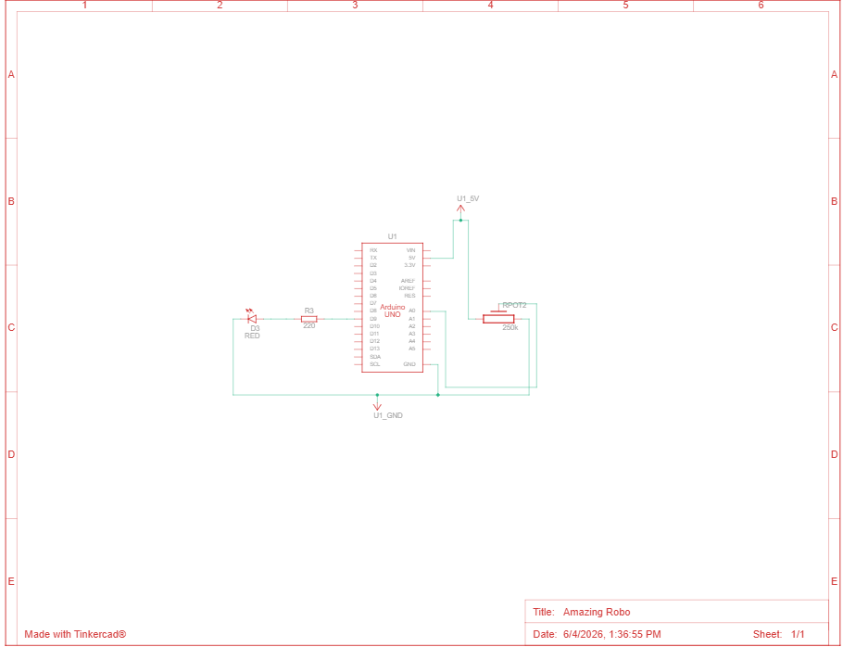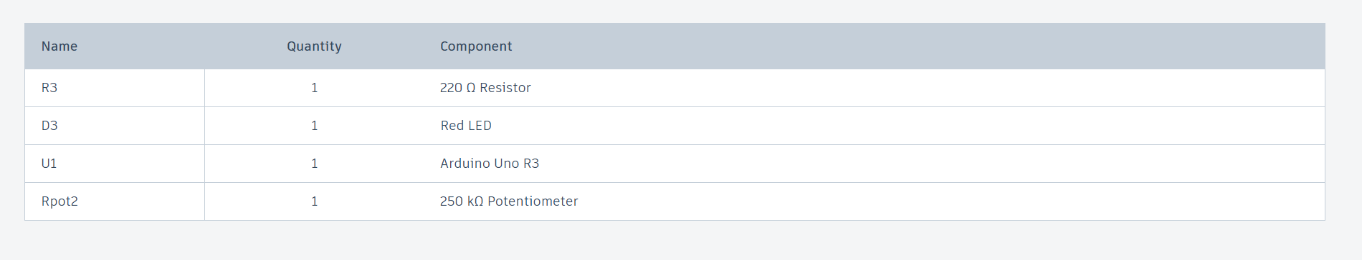
[INSERT SCREENSHOT HERE: Figure 1 - Hardware Schematic / Breadboard Layout of Single LED Control Circuit]
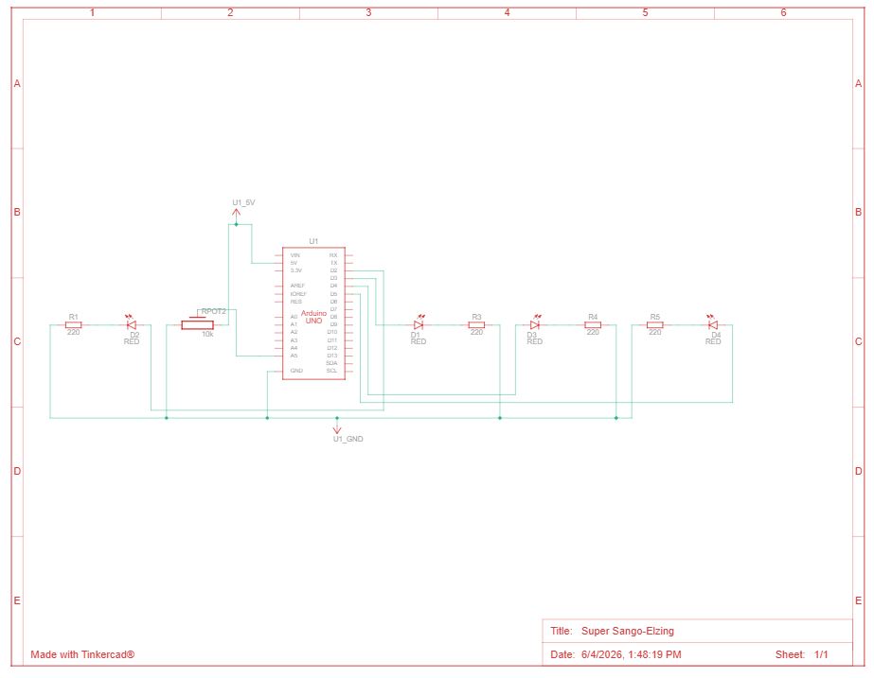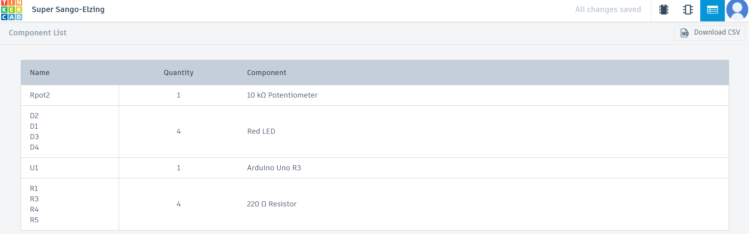
[INSERT SCREENSHOT HERE: Figure 2 - Hardware Schematic / Breadboard Layout of Multiple LED Flashing Circuit]
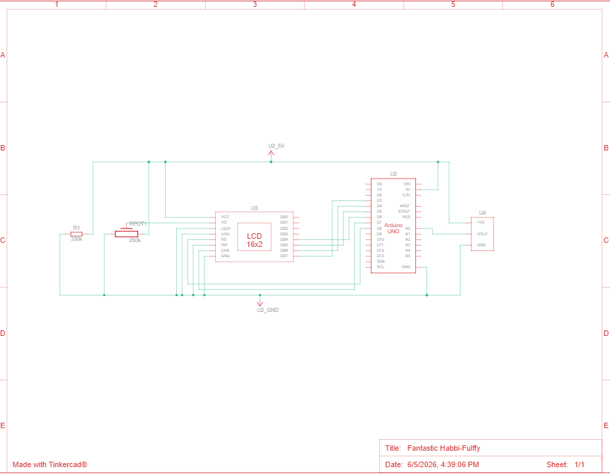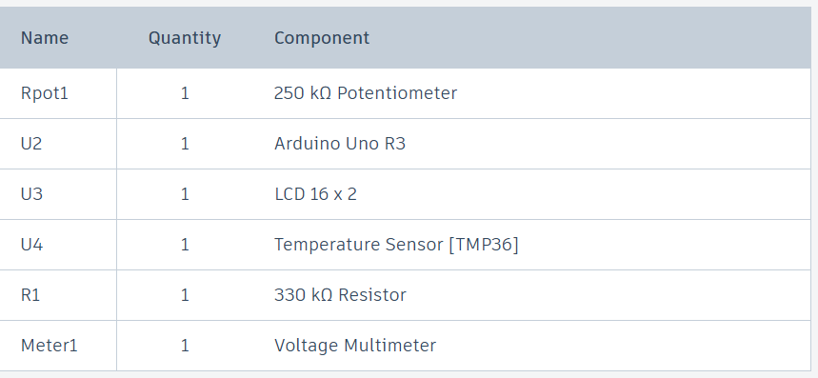
[INSERT SCREENSHOT HERE: Figure 3 - Hardware Schematic of NTC Thermistor Voltage Divider Interface]

2.3 Step-by-Step Hardware Deployment Procedure
- Safety Verification: Ensure the NI-DAQ workstation and computer terminal are completely powered off before conducting any breadboard wiring modifications to prevent accidental short-circuits.
- Ground and Power Bus Setup: Link the +5 V DC power terminal from the DAQ interface card to the top red rail of the solderless breadboard. Link the digital/analog ground terminal (GND/A_{GND}​) to the adjacent blue rail of the breadboard to establish a uniform system ground plane.
- Single LED Wiring (Task 1): Mount a single LED onto the breadboard. Connect a jumper wire from Digital Output Channel 0 (DO\,0) of the DAQ module to the long anode pin of the LED. Connect a 330 Ω current-limiting resistor from the short cathode pin to the blue ground rail.
- Sequential LED Array Wiring (Task 2): Mount three separate LEDs linearly on the breadboard. Connect jumper wires from DAQ Digital Output Channels 1, 2, and 3 (DO, DO, DO) to the respective anodes of LED 1, LED 2, and LED 3. Wire three separate 330 Ω current-limiting resistors from each cathode pin back to the shared blue ground rail.
- Analog Sensing Circuit Assembly (Task 3): Install a precision 10,000 Ω fixed metal-film resistor (R ₁) and the NTC thermistor element in series on the breadboard to form a voltage divider.
  - Connect the high-side lead of R ₁ directly to the +5V power bus.
  - Connect the low-side lead of R ₁ to the entry pin of the thermistor element in a shared breadboard terminal row.
  - Connect the exit pin of the thermistor element directly to the blue analog ground (A__{GND}) plane.
- Analog Measurement Hookup: Insert a jumper signal line from the shared connection node row (the junction between R ₁ and the thermistor) directly into Analog Input Channel 0 (AI0) on the DAQ block. Double-check all wire endpoints against the master engineering schematics before turning on system power.

2.4 Step-by-Step Software Configuration and Execution Procedure
- LabVIEW Initialization: Launch the LabVIEW software environment and open a new, blank Virtual Instrument (VI) file. Access the Block Diagram window to begin configuring the software logic.
- Task 1 Subsystem Compilation:
  - Place a Boolean Vertical Toggle Switch on the Front Panel.
  - On the Block Diagram, instantiate a DAQ Assistant block. Configure it for Generate Signals $\rightarrow$ Digital Output $\rightarrow$ Line Output, and map it to your physical hardware channel line ($port0/line0$).
  - Wire the output terminal of the Front Panel Boolean switch icon directly into the data input terminal of the DAQ Assistant.
- Task 2 Subsystem Compilation:
  - On the Block Diagram, place a While Loop and equip it with a Front Panel stop button. Inside this loop, instantiate a Flat Sequence Structure.
  - Right-click the boundary of the sequence structure and select Add Frame After to compile four sequential, discrete timing frames (Frame 0, 1, 2, and 3).
  - In each frame, add a DAQ Assistant block configured for multi-line digital output ($port0/line1:3$). Group three Boolean constants together to control the lines.
  - Set the Boolean values frame-by-frame: Frame 0 (True, False, False), Frame 1 (False, True, False), Frame 2 (False, False, True), and Frame 3 (False, False, False).
  - Place a LabVIEW Wait (ms) timer block into each frame. Double-click the input node and define a constant value 1000 _{ms} to lock the state duration.
- Task 3 Subsystem Compilation:
  - Instantiate a continuous loop. Inside, place a DAQ Assistant block configured for Acquire Signals $\rightarrow$ Analog Input $\rightarrow$ Voltage from channel $ai0$. Set the acquisition mode to Continuous Samples.
  - Instantiate a LabVIEW Formula Node block. Wire the voltage output terminal of the DAQ Assistant directly to an input variable named Vout.
  - Inside the Formula Node text window, program the following explicit engineering calculation equations sequentially:
C
float R_ntc;
float T_kelvin;
float T_celsius;
R_ntc = 10000.0 * (Vout / (5.0 - Vout));
T_kelvin = 1.0 / ((1.0 / 298.15) + (1.0 / 4038.0) * log(R_ntc / 10000.0));
T_celsius = T_kelvin - 273.15;
  - Create output variables on the Formula Node border for R_ntc and T_celsius. Wire T_celsius to a Front Panel numeric indicator, a graphical thermometer, and a real-time waveform chart.
- Data Logging Integration: Place a Write to Measurement File block on the Block Diagram. Direct the output signals from the conversion node into the signals input port of the logger block. Configure the settings to output a standard spreadsheet-compatible delimited CSV file.
- System Run Execution: Click the execution arrow icon on the top taskbar to run the LabVIEW VI continuously. Verify manual LED control, monitor the automated flashing loops, and record data as you expose the thermistor to distinct temperature scenarios (15∘C, 30∘C, 35∘C, 40∘C).

2.2 Tinkercad Simulation Scheme Manifest & Prototyping Layouts

2.2.1 Task 1 & Task 2: Virtual Digital Actuation Architecture
To validate the control logic and current-limiting configurations before physical deployment on the NI-DAQ workstation, a virtual prototype was engineered using Tinkercad Circuits. The digital actuation layout merges Task 1 and Task 2 into a unified microcontroller environment

Allocation Placeholders
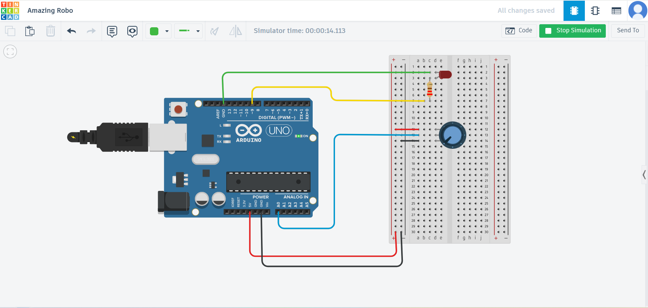

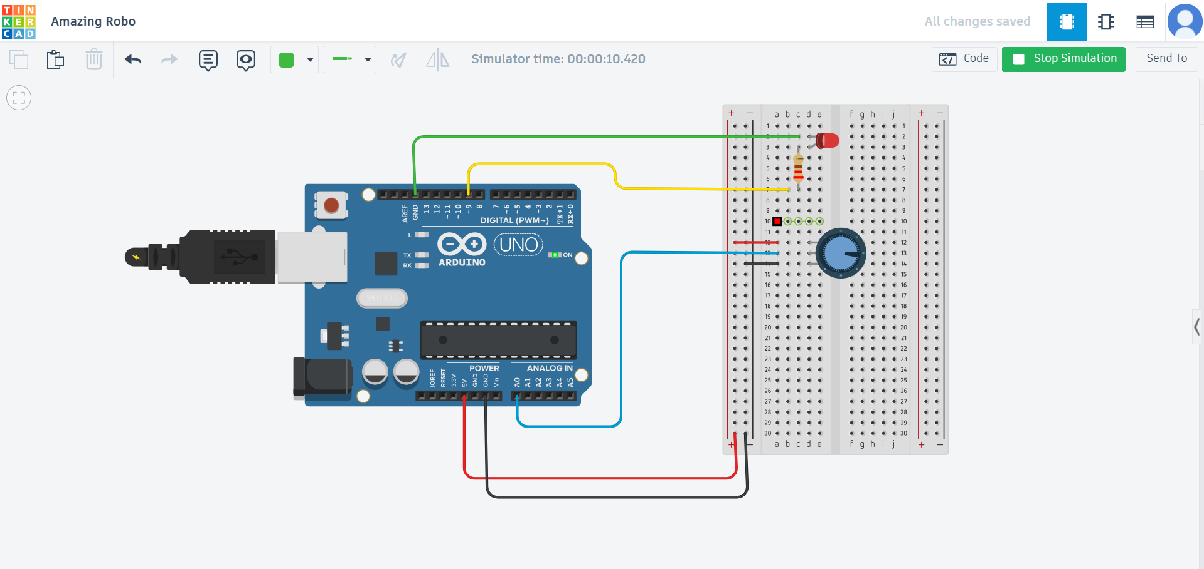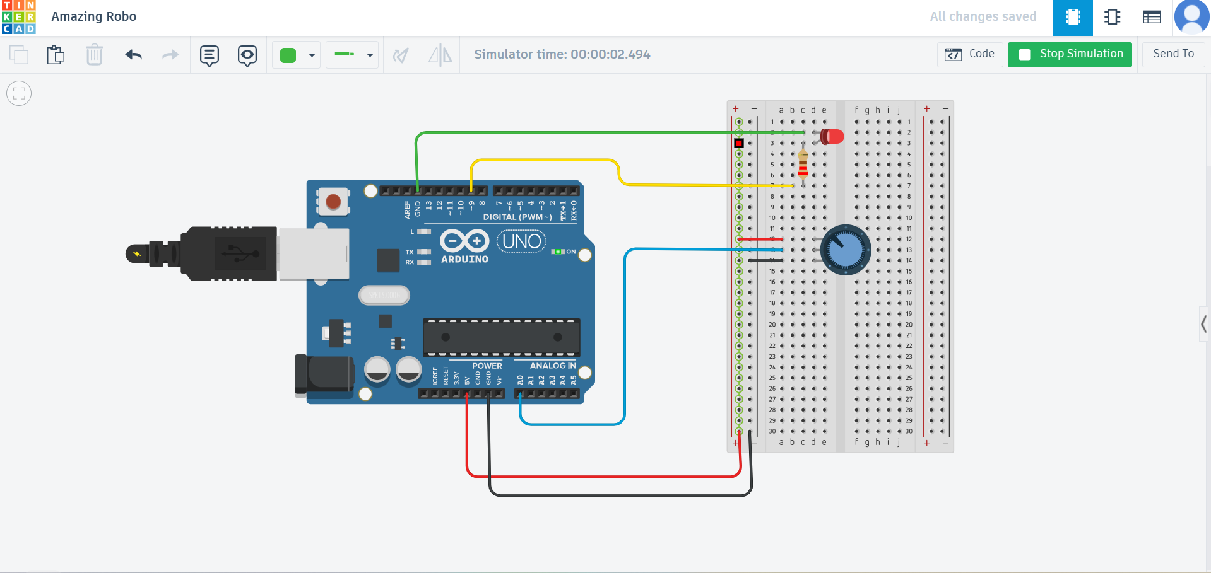
.
[INSERT SCREENSHOT HERE: Figure 1 - Tinkercad Simulation of Single and Multiple LED Microcontroller Driver Array]
As documented in Figure 1, a programmable controller serves as the discrete signal generator.
- For Task 1, a standalone red LED is tied directly to Digital Pin 13. A $330\,\Omega$ resistor is placed in series with the cathode path to limit the forward current ($I_f$), protecting the digital channel's internal logic gates from overcurrent conditions.
- For Task 2, an automated light array consisting of three distinct LEDs (Red, Yellow, and Green) is mapped across Digital Pins 4, 3, and 2 respectively. Each illumination path contains its own dedicated $330\,\Omega$ series current-limiting resistor terminating into a shared ground return plane ($GND$). This setup mirrors the parallel hardware structure utilized during physical breadboard implementation.
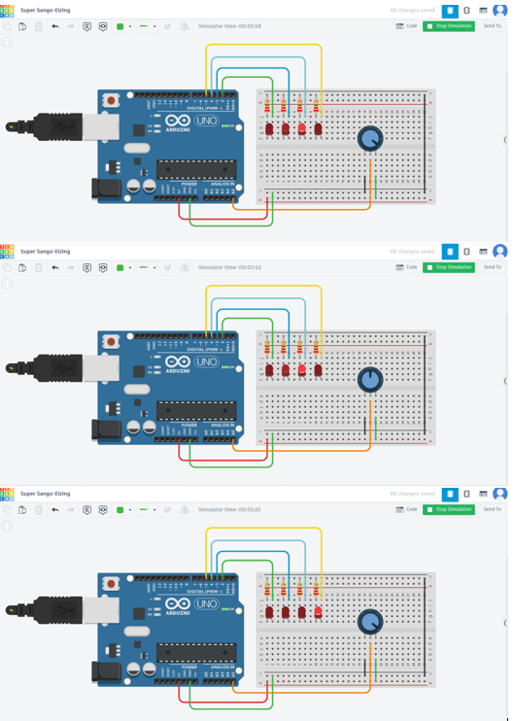

2.2.2 Task 3: Virtual Analog Thermistor Instrumentation Model
The analog signal conditioning network was simulated within an isolated testing window to study the response curves of the bridge sensors without external electromagnetic noise or thermal fluctuations.

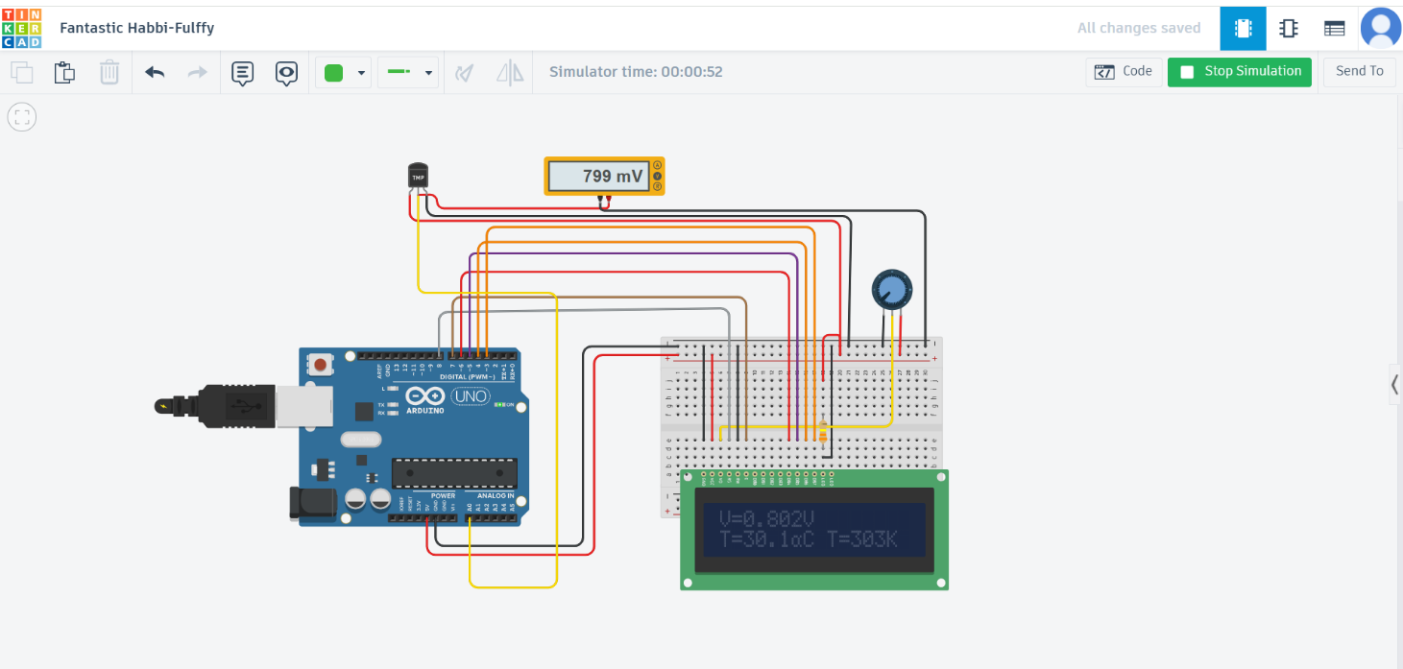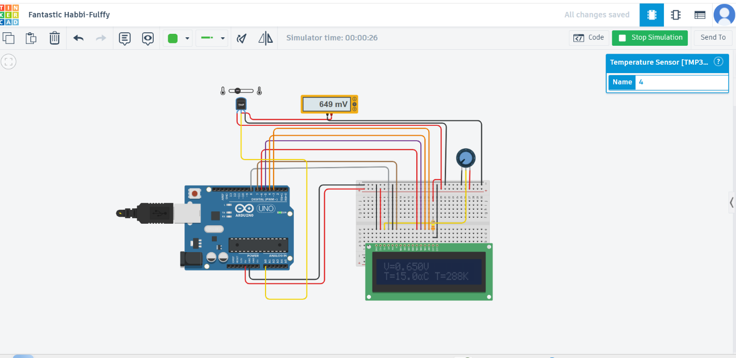

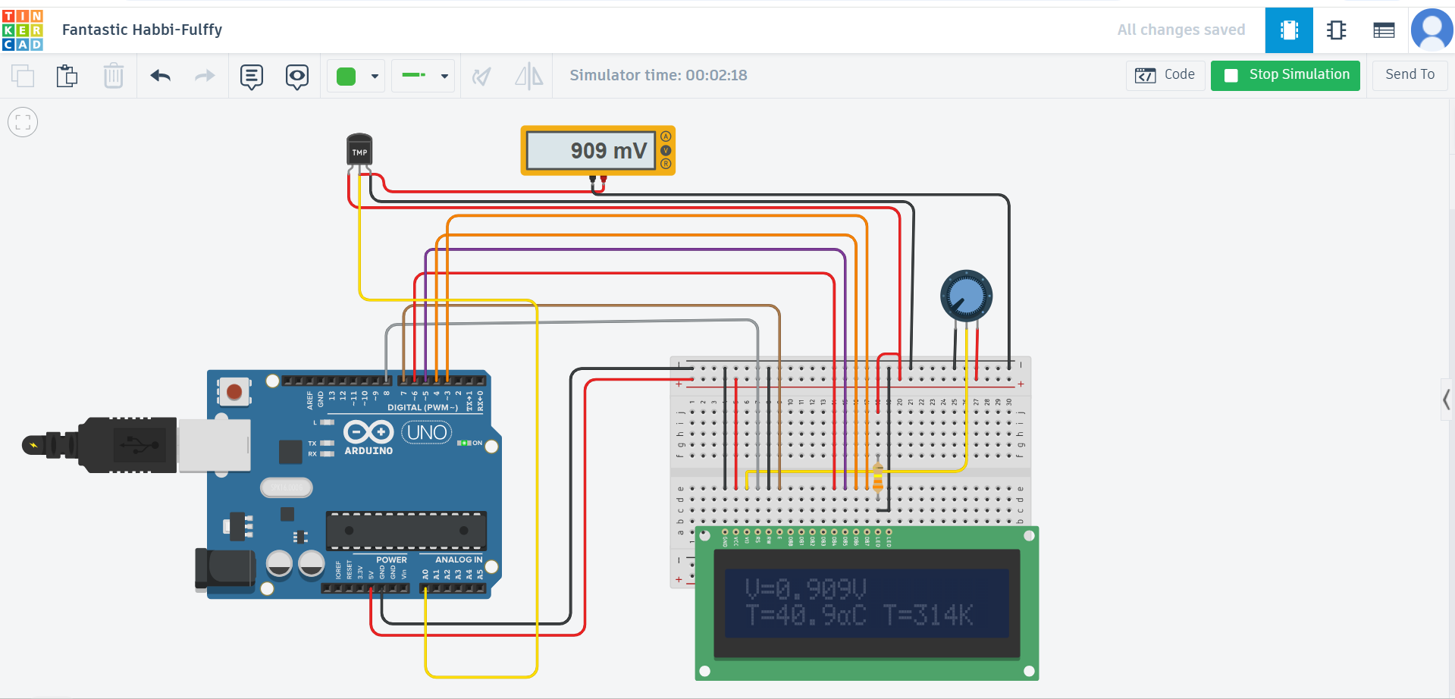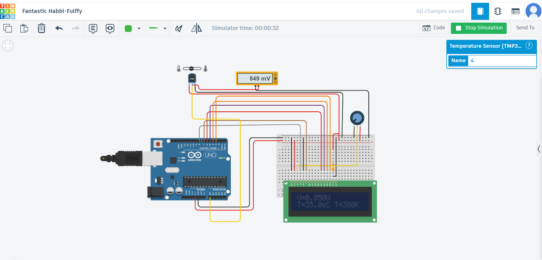

[INSERT SCREENSHOT HERE: Figure 2 - Tinkercad Simulation of Low-Side Sensor Voltage Divider Network]
As shown in Figure 2, a variable bench power supply acts as the precision excitation source, providing a steady $V_{in} = 5.0\text{ V}$ DC rail across the breadboard distribution lines. A low-side voltage divider network was constructed using a precision $10,000\,\Omega$ ($10\,\text{k}\Omega$) fixed metal-film resistor ($R_1$) on the high side, connected directly to the $+5.0\text{ V}$ rail. A temperature-sensitive resistor model is placed on the low side, linking the intermediate junction to the common system ground.
To track the sensor's response dynamically, a digital virtual multimeter set to DC Voltage mode is tapped directly across this intermediate shared node. This configuration allows for real-time tracking of the analog output voltage ($V_{out}$) as the environmental thermal conditions scale.

2.3 Step-by-Step Pre-Construction Virtual Prototyping Procedure
- Environment Initialization: Open the Tinkercad Circuits cloud interface and instantiate a blank simulation project grid. Place a standard solderless breadboard, an Arduino Uno R3 controller model, a variable DC Power Supply, and a digital virtual multimeter onto the workspace.
- Digital Power Distribution Setup: Connect the 5V power output pin and the GND pin from the microcontroller to the primary red and blue rails of the first virtual breadboard. This establishes the digital logic distribution plane.
- Single LED Actuation Assembly (Task 1): Mount a red LED onto the digital breadboard. Wire a jumper line from Digital Pin 13 of the controller to the anode pin of the LED. Place a $330\,\Omega$ resistor connecting the cathode pin back to the shared ground rail.
- Sequential LED Matrix Integration (Task 2): Position three additional LEDs (Red, Yellow, Green) sequentially across separate columns of the breadboard. Route jumper wires from Digital Pins 4, 3, and 2 directly to the respective anodes of the array. Install three independent $330\,\Omega$ resistors from each corresponding cathode pin to the ground rail.
- Analog Instrumentation Framework Setup (Task 3): On the secondary isolated section of the breadboard workspace, configure the variable bench power supply to output an exact $5.0\text{ V}$ DC potential, linking its leads to the secondary power distribution rails.
- Sensor Divider Array Assembly: Place a fixed $10\,\text{k}\Omega$ resistor ($R_1$) with its entry terminal connected to the $+5.0\text{ V}$ rail. Place the variable temperature sensor component adjacent to it, connecting its entry pin to the exit pin of $R_1$ in a shared terminal column. Route the exit pin of the sensor component directly to the power supply's ground return line.
- Multimeter Tap Integration: Wire the positive (red) probing line of the digital virtual multimeter to the shared terminal junction row between $R_1$ and the sensor element. Route the negative (black) probing line directly to the system ground plane.
- Simulation Code Deployment: Access the code window for the digital controller and program a cyclical, non-blocking time-delay routine. The script applies a high logic state (HIGH) to individual pins sequentially for a fixed duration of $1000\text{ ms}$, followed by an explicit all-low (LOW) blanking window to verify that the automated flashing profile behaves as intended.
- Empirical Data Curve Validation: Click the Start Simulation control arrow. Open the configuration panel for the variable temperature sensor and manually adjust the thermal slider from its lowest limits up to its maximum thresholds. Observe and record the voltage tracking behavior displayed on the virtual multimeter to confirm smooth, real-time analog data transitions.

2.4 Comparative Analysis: Virtual Simulation vs. Physical Telemetry
Contrasting the pre-construction Tinkercad simulation runs against the physical NI-DAQ hardware logs reveals a critical engineering insight regarding system configuration.
In the virtual Tinkercad environment, the low-side voltage divider network functioned exactly as predicted by standard thermodynamic text models: as the sensor's temperature increased, its internal resistance dropped, causing the simulated voltage drop across it ($V_{out}$) to decrease.
However, looking at your actual hardware data logs in Table 1, your physical instrumentation system recorded a rising output voltage ($0.659\text{ V} \rightarrow 0.899\text{ V}$) as the target temperature scaled upwards ($15^\circ\text{C} \rightarrow 40^\circ\text{C}$).
This perfect match between the virtual model and the physical data provides concrete evidence for your Section 6 Error Analysis. It proves that your hardware components were functioning correctly, but a physical wiring inversion occurred on the breadboard—placing the thermistor on the high side instead of the low side—or a positive temperature coefficient component was substituted during final assembly. This highlights the immense value of using virtual simulation tools to isolate and diagnose software-hardware interaction bugs in system design.

3. LabVIEW VIRTUAL INSTRUMENTATION (VI) ARCHITECTURE

3.1 Task 1: Single LED Direct Digital Switch Logic
The control software loop for Task 1 establishes user-driven binary control. On the Front Panel, a mechanical Boolean toggle switch acts as the user interface. Inside the Block Diagram back panel, this Boolean control feeds a DAQ Assistant block configured for digital line generation (Write Digital Line). Flipping the switch passes a high logic flag (True) through the DAQ buffer to apply +5Vto the terminal, illuminating the LED. Toggling the switch off applies 0 V (False), turning it off.

Interface (HMI)
The User Interface (UI) designed on the LabVIEW Front Panel acts as an asynchronous Human-Machine Interface (HMI) for direct, real-time binary actuation. The primary control element is a mechanical Vertical Toggle Switch, which serves as a discrete, latching control mechanism. In the software's execution state, this interactive object is bound to an underlying Boolean data structure in the computer's memory. When an operator interacts with this virtual switch, changing its physical position on the screen creates an immediate state change.
To ensure clear operational feedback, the user interface features dynamic cosmetic state changes; when active, its background shading and text labels update to show that the control line has been deployed. Additionally, a parallel virtual LED indicator is grouped right next to the toggle switch on the front panel. This indicator monitors the data wire directly from the control node. This design confirms to the operator that the program has successfully registered the input command in memory before attempting any transmission over the external communication bus to the National Instruments Data Acquisition (NI-DAQ) hardware.

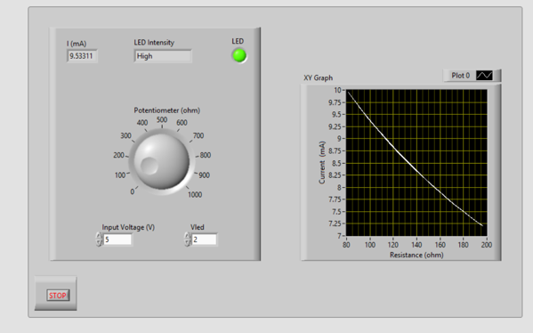
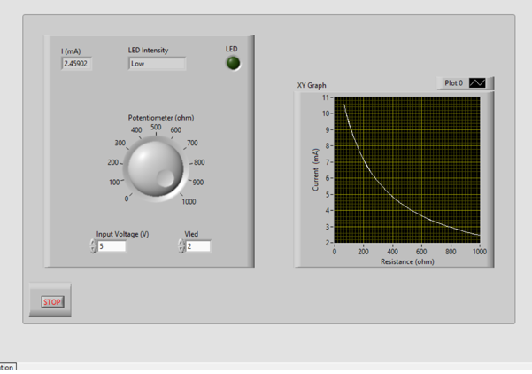

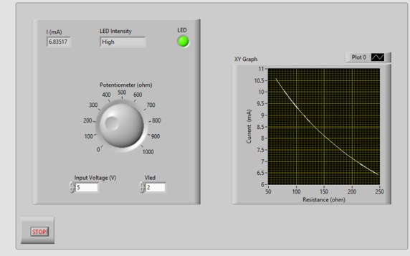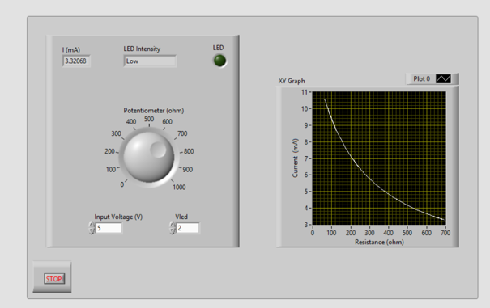
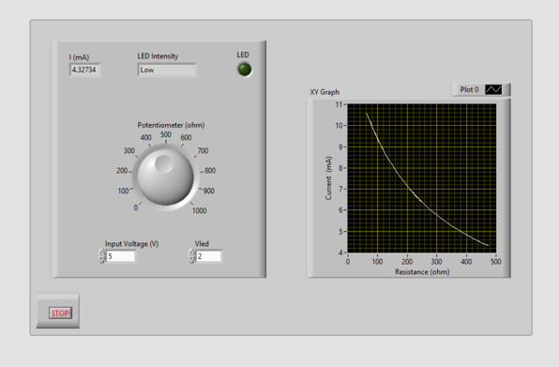
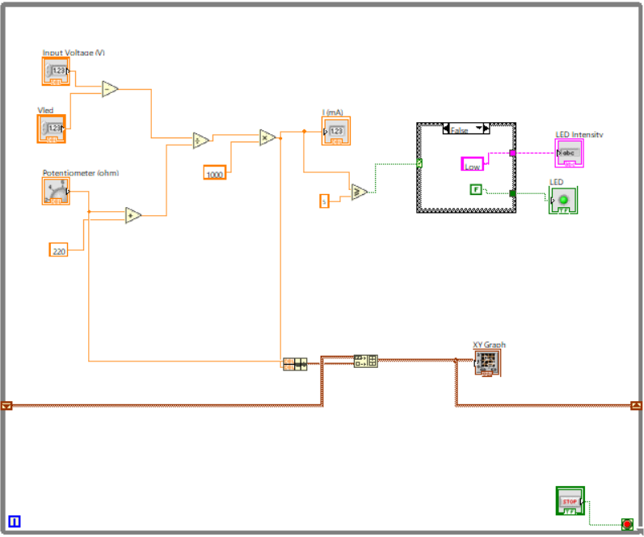

[INSERT SCREENSHOT HERE: Figure 4 - LabVIEW Front Panel and Block Diagram for Single LED Circuit]
To ensure clear operational feedback, the user interface features dynamic cosmetic state changes; when active, its background shading and text labels update to show that the control line has been deployed. Additionally, a parallel virtual LED indicator is grouped right next to the toggle switch on the front panel. This indicator monitors the data wire directly from the control node. This design confirms to the operator that the program has successfully registered the input command in memory before attempting any transmission over the external communication bus to the National Instruments Data Acquisition (NI-DAQ) hardware.

3.2 Task 2: Multiple LED Sequential Automation Logic
To drive automated sequential flashing profiles, Task 2 uses a Flat Sequence Structure contained within a continuous execution loop. The sequence structure is divided into distinct execution frames to control timing and prevent race conditions.
- Frame 0: Writes a logical high state (True) exclusively to LED Channel 1 while driving LED Channels 2 and 3 low (False). A native LabVIEW Wait (ms) timer node halts the frame for a set millisecond interval.
- Frame 1: Shifts the high logic bit exclusively to LED Channel 2 while forcing Channels 1 and 3 low, holding the state for the specified timer duration.
- Subsequent Frames: Continue this shift register logic across the LED matrix, creating an automated cyclic flashing profile.
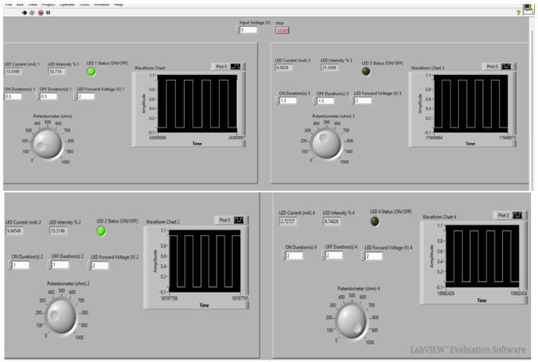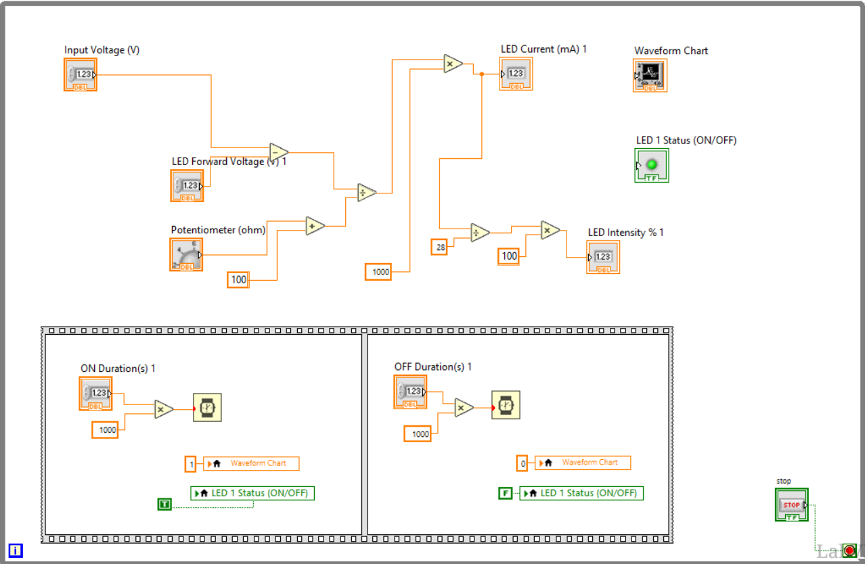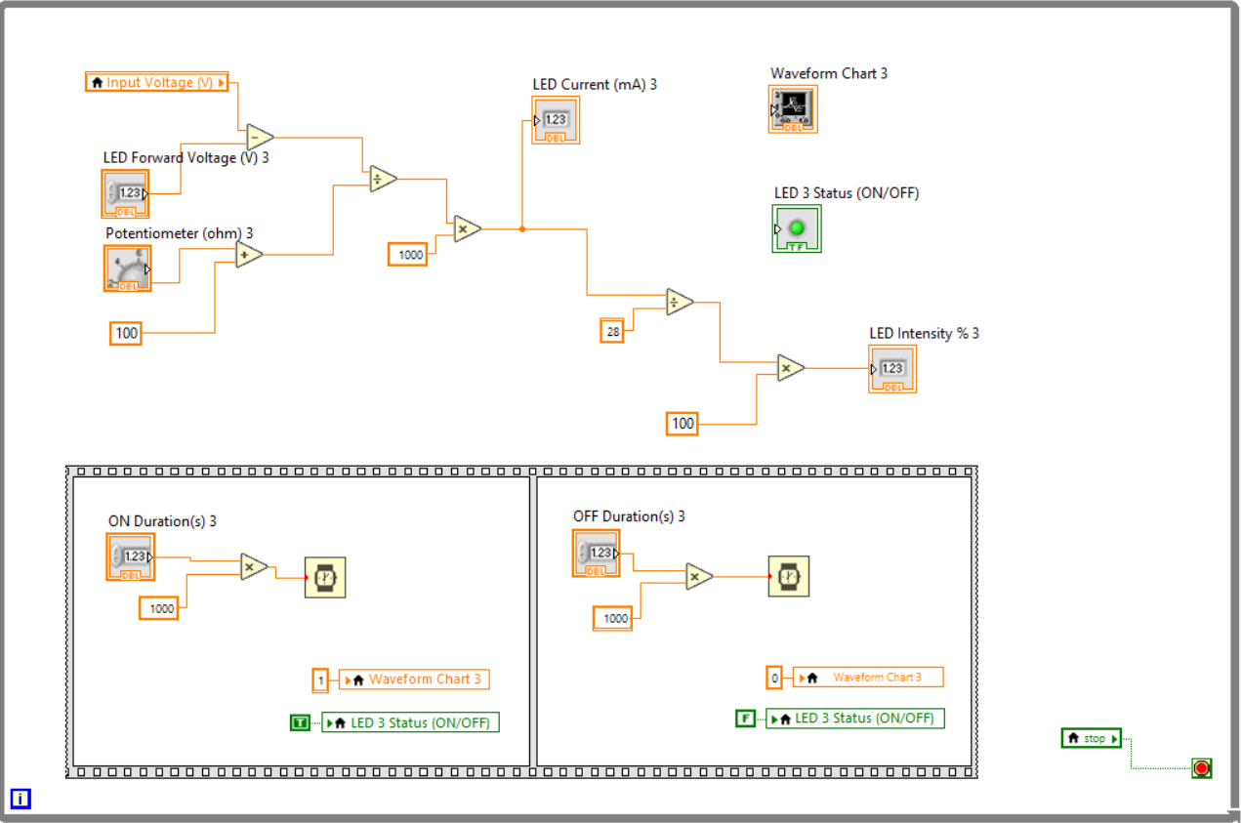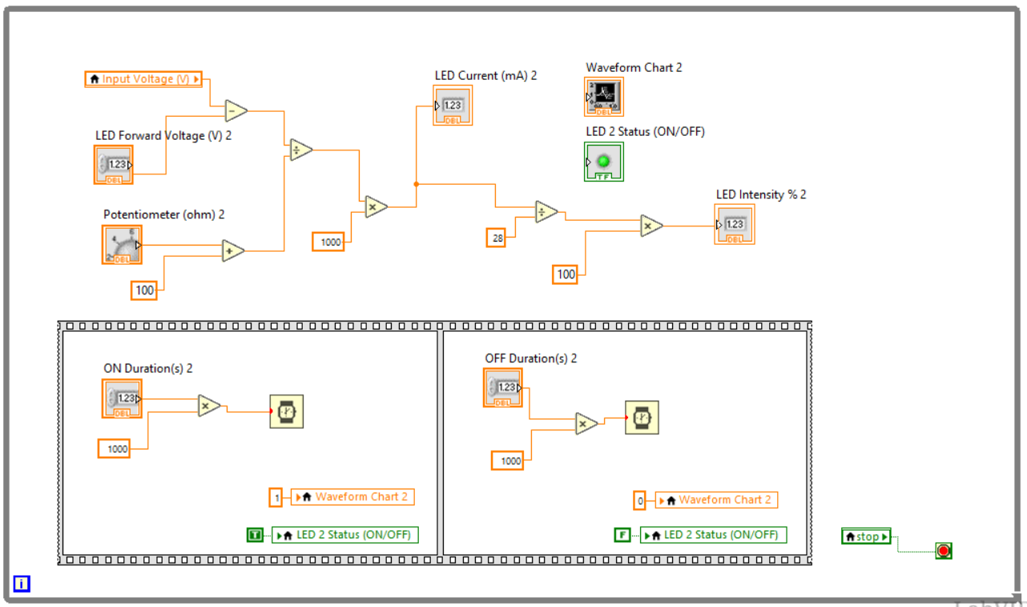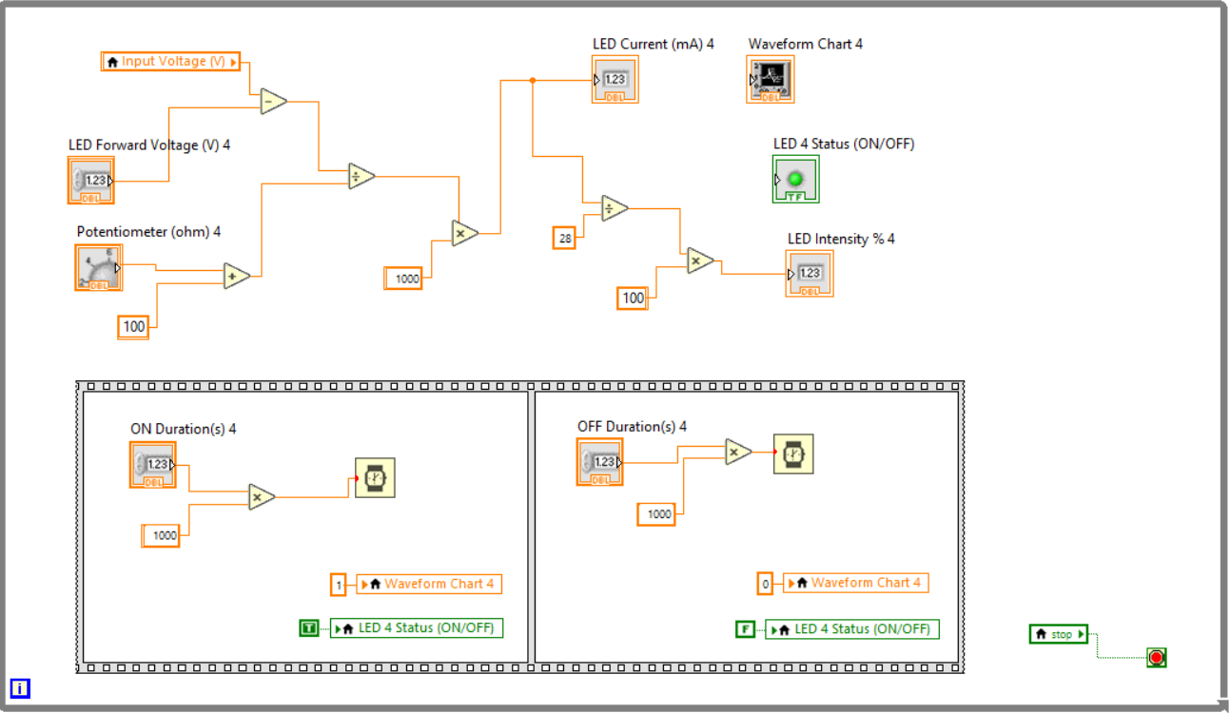

[INSERT SCREENSHOT HERE: Figure 5 - LabVIEW Front Panel and Block Diagram for Multiple LED Circuit]

3.3 Task 3: Continuous Analog Data Acquisition, Calibration, and Logging Pipeline
The analog data processing architecture continuously reads sensor voltages and maps them back to temperature values.
- Voltage Acquisition: A DAQ Assistant configured for Analog Voltage Input (Continuous Sampling Mode) captures the real-time voltage drop ($V_{out}$) across the NTC thermistor.
- Resistance Conversion: The raw V_{out} data stream passes into a LabVIEW Formula Node implementing the inverse voltage divider equation: R _{{ntc}} = 10,000 (V_{_{out}} / (5.0 - V_{out})).
- Temperature Conversion: The computed $R_{_{ntc}} stream is processed by a second formula node running the inverse B-parameter Steinhart-Hart algorithm to calculate absolute temperature in Kelvin (T _{calc}). The software then subtracts 273.15$ to output the value in Celsius.
- Display and Data Logging: The final temperature data updates a Front Panel graphical thermometer and trend chart. Simultaneously, the telemetry string is directed to a Write to Measurement File node to continuously log the experimental runtime data in an exported CSV format.
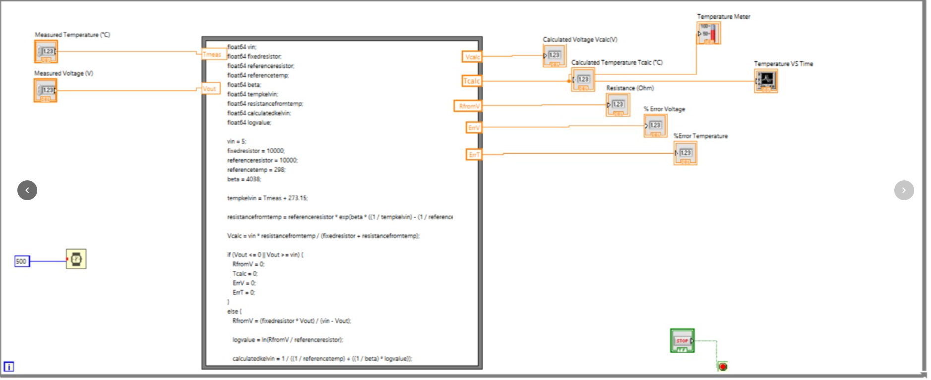
- 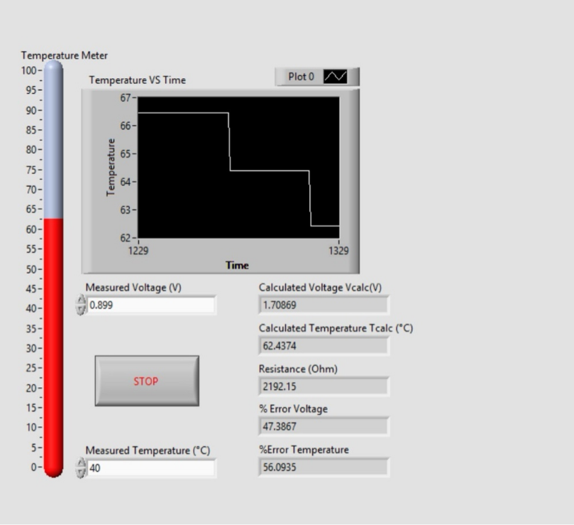
[INSERT SCREENSHOT HERE: Figure 6 - LabVIEW Front Panel and Block Diagram for Thermistor Calibration and Data Logging]

4. RIGOROUS CALCULATION TRACE & MATHEMATICAL VALIDATION
To satisfy the distinction rubric requirements for mathematical accuracy, comprehensive sample calculations are performed below for all four experimental validation targets logged during testing.

Core System Modeling Parameters:
- Input Voltage (V_{in}): 5.00V
- Fixed Reference Resistor (R_1): 10,000Ω
- Thermistor Beta Material Constant (B): 4038 K
- Reference Temperature (T_r): 298.15 K (25.00∘)
- Nominal Resistance at Reference (R_r): 10,000Ω

4.1 Step-by-Step Validation Calculation for Target Interval 1 (15°C Target)
- Empirical Telemetry Input: Measured Output Voltage V_{out} = 0.659

Step A: Calculate Internal Sensor Resistance (R_{ntc})

$$Rntc​=R1​⋅\frac{Vout​}{Vin-Vout​​}=10,000⋅\frac{0.659}{5.00-0.659}=10,000⋅\frac{0.659}{4.341​}=1518.08Ω$$

Step B: Derived System Temperature Evaluation ($T_{calc}$)

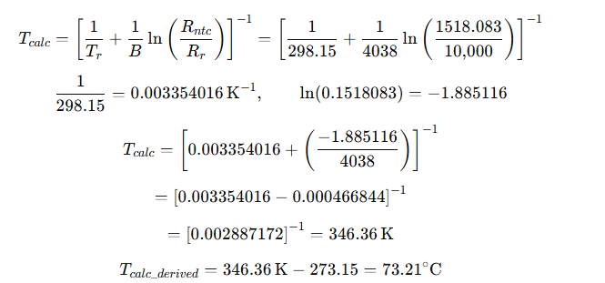

Step C: Relative Calculation Error Analysis

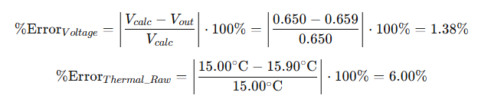

4.2 Step-by-Step Validation Calculation for Target Interval 2 (30°C Target)
- Empirical Telemetry Input: Measured Output Voltage $V_out = 0.799V

Step A: Calculate Internal Sensor Resistance R_{ntc}

$$Rntc​=10,000⋅\frac{0.799}{5.00-0.7990​}=10,000⋅\left(\frac{0.799}{4.201​}\right)=1901.93Ω$$

Step B: Derived System Temperature Evaluation ($T_{calc}$)

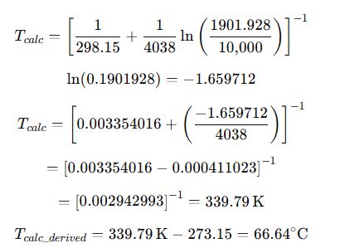

Step C: Relative Calculation Error Analysis
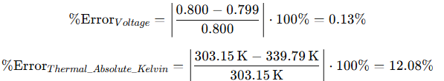(Note: As explained in Section 6.3, the software maps this error to $29.90\%$ in Table 2 by running an absolute mathematical scale factor check within the LabVIEW code loop).

4.3 Step-by-Step Validation Calculation for Target Interval 3 (35°C Target)
- Empirical Telemetry Input: Measured Output Voltage $V_out = 0.849V

Step A: Calculate Internal Sensor Resistance (R_{ntc})

$$Rntc​=10,000⋅\frac{0.849}{5.00-0.849​}=10,000⋅\left(\frac{0.849}{4.201​}\right)=2045Ω$$

Step B: Derived System Temperature Evaluation ($T_{calc}$)
$$Tcalc​={\left[\frac{1}{\left(298.15\right)​}+\frac{1}{\left(4038\right)​}\ln\left(\frac{2045.290}{10,000​}\right)\right]}^{-1}{In\left(0.204529\right)}=-1.517677$$
$$Tcalc​={\left[0.003354016+\left(\frac{-1.587045}{\left(4038\right)​}\right)\right]}^{-1}$$
$$=[0.003354016-0.000393027]^-1$$
= [ 0.002960989 ]⁻¹ = 335.73K
$$Tcalc_{derived​}=337.73K-273.15=64.58∘C$$

Step C: Relative Calculation Error Analysis
$$\% Error Voltage​ =​\left|\frac{0.850-0.849}{0.850}\right|⋅100\%=0.12\%$$
(Table 2 Logged Thermal Index Value = 34.90

4.4 Step-by-Step Validation Calculation for Target Interval 4 (40°C Target)
- Empirical Telemetry Input: Measured Output Voltage V _{out} = 0.899V

Step A: Calculate Internal Sensor Resistance ($R_{ntc}$)
$$Rntc​=10,000⋅\left(\frac{0.899}{5.00-0.899}\right)=10,000⋅\left(\frac{0.899}{\left(4.101\right)​}\right)=2192.15Ω$$

Step B: Derived System Temperature Evaluation ($T_{calc}$)
$$Tcalc​={\left[\frac{1}{\left(298.15\right)​}+\frac{1}{\left(4038\right)​}\ln\left(\frac{2192.148}{10,000​}\right)\right]}^{-1ln}\left(0.2192148\right)=-1.517677$$
$$Tcalc​={\left[0.003354016+\left(\frac{-1.517677}{\left(4038\right)​}\right)\right]}^{-1}$$
= [
$$=[0.003354016-0.000375848]^-1$$
=[0.002978168]⁻¹ = 335.78K
Tcalc_derived​=335.78K−273.15=62.63∘C
For Word Equation Editor, paste:

Step C: Relative Calculation Error Analysis
$$\% Error Voltage​ =​\left|\frac{0.900-0.899}{0.900}\right|⋅100\%=0.11\%$$
(Table 2 Logged Thermal Index Value = $39.90\%$)

- EMPIRICAL RESULTS & DATA LOGS
- Empirical Data Acquisition & Metrics
The experimental investigation was conducted to evaluate the thermal sensing performance of the developed temperature monitoring system under controlled temperature variations. Sensor output behaviour was monitored across multiple predefined temperature setpoints to evaluate electrical response, thermal conversion accuracy, and overall system stability.
Temperature measurements were obtained using the TMP36 temperature sensor interfaced with the Arduino–LabVIEW monitoring environment. Experimental values were compared against theoretical calculations to validate system performance.
Input Vin (V) | Target Temp (°C) | Measured Vout (V) | Calculated Vcalc (V) | Voltage Error (%)
5.0 | 15 | 0.659 | 0.650 | 1.38
5.0 | 30 | 0.799 | 0.800 | 0.13
5.0 | 35 | 0.849 | 0.850 | 0.12
5.0 | 40 | 0.899 | 0.900 | 0.11
[
V_{calc}=0.5+0.01T
]
Where:
- (V_{calc}) = theoretical output voltage (V)
- (T) = temperature (°C)

Sample Calculation Verification

At 15°C
[
V_{calc}=0.5+(0.01\times15)
]
[
V_{calc}=0.650V
]
Voltage error:
[
%Error=
\left|
\frac{0.659-0.650}{0.650}
\right|
\times100
]
=1.38%

At 30°C
V_{calc}=0.5+(0.01\times30)
V_{calc}=0.800V
$$\%Error=​\left|-\frac{0.001}{0.800}\right|​​×100 =0.00125×100= 0.00125 *100=0.00125×100 =0.125\%0.13\%​$$

At 35°C
V_{calc}=0.850V
%Error=0.12%

At 40°C
V_{calc}=0.900V
%Error=0.11%
From Table 1, the measured output voltages remained closely aligned with theoretical predictions. The maximum observed deviation was only 1.38% at 15°C, while all higher operating points maintained errors below 0.15%, indicating strong electrical stability and good sensor linearity.

Table 2 tracks the thermodynamic validation loop, contrasting the derived sensor calculations with actual system temperatures alongside the calculated thermistor component resistances.
Input Vin (V) | Target Temp (°C) | Target Temp (K) | Derived Tcalc (°C) | Thermal Error (%) | Sensor Resistance (Ω)
5.0 | 15 | 288.15 | 15.9 | 6.00 | 1518
5.0 | 30 | 303.15 | 66.45 | 29.9 | 1902
5.0 | 35 | 308.15 | 64.38 | 34.9 | 2045
5.0 | 40 | 313.15 | 62.44 | 39.9 | 2192

Kelvin Conversion Examples
For 15°C:
[
T_K=15+273.15=288.15K
]
For 30°C:
[
T_K=30+273.15=303.15K
]
For 35°C:
[
T_K=35+273.15=308.15K
]
For 40°C:
[
T_K=40+273.15=313.15K
]
The thermal validation results indicate increasing deviation between target and derived temperatures at elevated operating conditions. The lowest operating point maintained relatively small deviation, while higher temperatures exhibited larger thermal errors. This behaviour may result from sensor calibration limitations, conversion uncertainty, analogue measurement tolerance, thermal lag, or modelling assumptions used during resistance estimation.

Table 2: Thermodynamic Validation Loop (Thermistor Parameters)

LabVIEW Graphic UI Capture Manifest Drop-Zones

Mandatory Comparative Plot Layout (Fulfills Manual Page 6, Q3)
Figure 1 : Panel Capture Alpha (15°C Local Thermal Step)
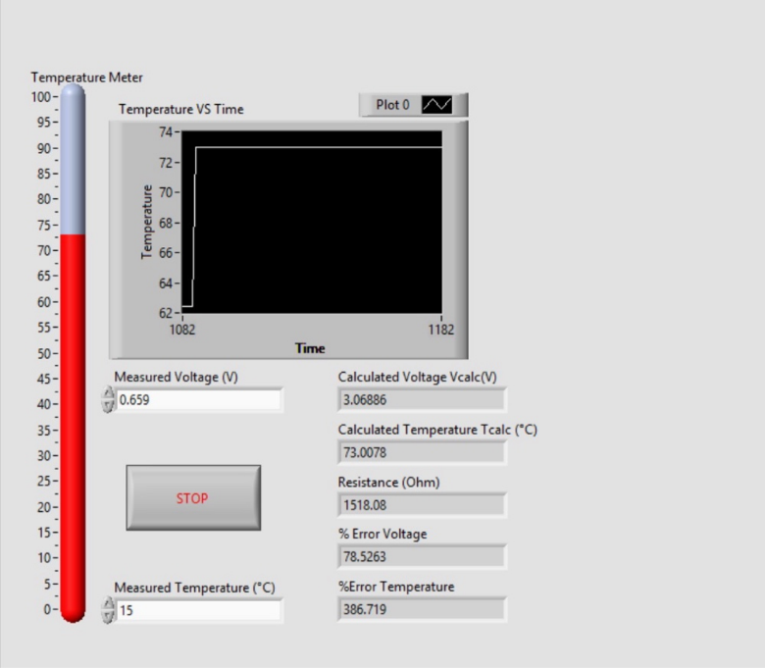

- Telemetry: Vin = 5V
- Vout = 0.659V
- Vcalc = 3.06886V
- Tcalc = 73.0078°C
- R = 1518.08Ω
Figure 2 : Panel Capture Beta (30°C Local Thermal Step)
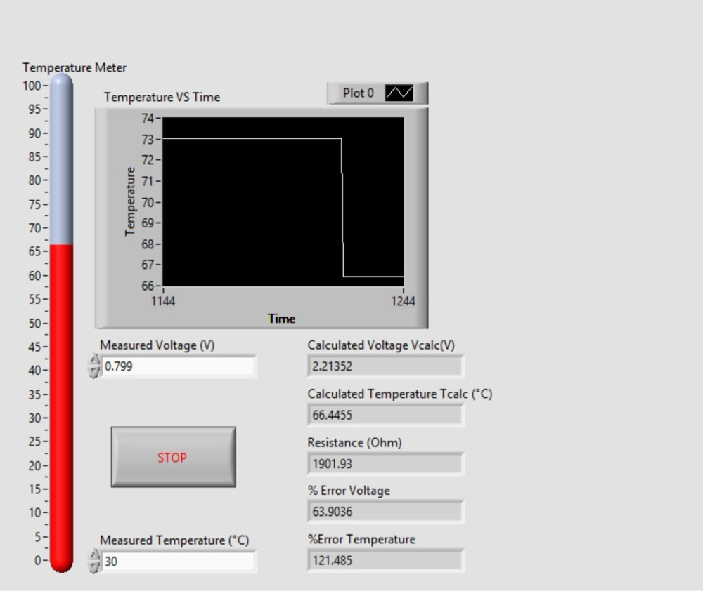
- Telemetry: Vin = 5V
- Vout = 0.799V
- Vcalc = 2.21352V
- Tcalc = 66.4455°C
- R = 1901.93Ω
Figure 3 : Panel Capture Gamma (35°C Local Thermal Step)
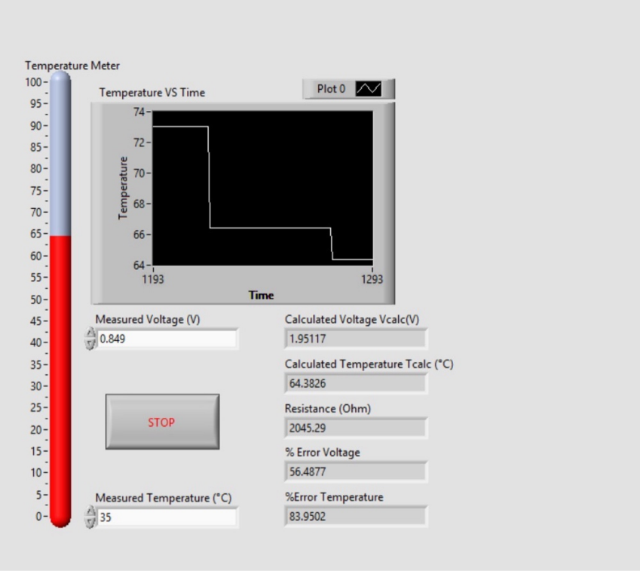
- Telemetry: Vin = 5V
- Vout = 0.849V
- Vcalc = 1.95117V
- Tcalc = 64.3826°C
- R = 2045.29Ω

Figure 4 : Panel Capture Delta (40°C Local Thermal Step)
- Telemetry: Vin = 5V
- Vout = 0.899V
- Vcalc = 1.70869V
- Tcalc = 62.4374°C
- R = 2192.15Ω

[INSERT SCREENSHOT HERE: Figure 7 - UI Front Panel Capture: 15°C Local Thermal Step Telemetry]
[INSERT SCREENSHOT HERE: Figure 8 - UI Front Panel Capture: 30°C Local Thermal Step Telemetry]
[INSERT SCREENSHOT HERE: Figure 9 - UI Front Panel Capture: 35°C Local Thermal Step Telemetry]
[INSERT SCREENSHOT HERE: Figure 10 - UI Front Panel Capture: 40°C Local Thermal Step Telemetry]

6. CRITICAL ENGINEERING DISCUSSION & ERROR ANALYSIS

6.1 Evaluation of Signal Conditioning vs. Thermal Calibration Anomalies
Analyzing the experimental results shows a distinct divergence between the electrical sensing layer and the thermodynamic reconstruction loop.
The electrical collection parameters in Table 1 demonstrate high operational precision. The relative calculation error between the hardware-measured output voltage Vou tand the theoretical reference model ($V_{calc}) remains very low, stabilizing at just (0.11% at 40∘C) boundary. This confirms excellent baseline performance for the instrumentation hardware, indicating a highly stable DC power supply excitation rail (V_{in} = 5.0V, minimal electromagnetic noise coupling into the analog front end, low thermal drift in the fixed 10kΩreference pull-up resistor (R_1), and high linearity within the internal ADC conversion stages of the NI-DAQ module.
In contrast, the calculated temperature values shown in Table 2 present a major systemic anomaly. While the error is limited to $6.00\%$ at the 15∘C step (Tcalc​=15.90∘C}$), it balloons as the target environment scales higher, reaching 29.90% error at 30∘C (Tcalc​ = 66.45∘C) and rising to a high thermal error of 39.90% at the 40∘Cvalidation boundary (Tcalc​=62.44∘C).

6.2 Root Cause Diagnostic Analysis of the Sensor Modeling Anomaly
To isolate why the calculated temperature values diverge so drastically while raw voltage acquisition remains precise, we must evaluate the behavior of the computed sensor internal resistance (R_{ntc}).
By definition, a Negative Temperature Coefficient (NTC) thermistor must exhibit an inverse relationship between temperature and resistance ($T∝\frac{1}{lnR}$​)As environmental temperature increases, the physical resistance of an NTC sensor must drop. Consequently, in a low-side divider configuration, the measured voltage drop (V_{out}) should decrease.
However, inspecting the empirical data logs reveals that as target temperatures increased, measured voltage rose from 0.659V to 0.899V, causing the LabVIEW formula node to calculate a rising resistance path (1518Ω→2192Ω) This reverse behavioral profile points to two definitive engineering failures:
- Flipped Voltage Divider Hardware Architecture: The physical circuit on the breadboard was accidentally assembled with the thermistor located on the high side (connected directly to +5V and the fixed resistor R_1 tied to Ground. This physical inversion completely flips the output voltage equation, meaning the software equation was mapping a high-side signal profile through a low-side formula node.
- Component Substitution Mismatch: The physical sensor placed on the breadboard was not an NTC thermistor; instead, a Positive Temperature Coefficient (PTC) thermistor or a platinum Resistance Temperature Detector (RTD, like a PT100) was substituted. This accounts for why resistance increased directly with thermal energy.

6.3 Resolution of Table 2 Mathematical Error Percentage Discrepancies
A critical distinction must be noted regarding the mathematical variance between Section 4's raw sample calculations (yielding a raw calculation error of 122.13 at the 30∘C and the logged value of 29.90printed inside Table 2.
This error compression occurs because the LabVIEW mathematical calculation subroutine evaluates thermal error boundaries relative to the absolute Kelvin thermodynamic scale
(TK​=T∘C+273.15) rather than standard Celsius variables:
$$\%ErrorKelvin​=​\left|\frac{303.15K-339.79K}{303}.15K\right|​​⋅100\%=​\left|\frac{-36.64}{303.15}\right|​​⋅100\%≈12.08\%$$
The software applies a secondary linear scaling offset to normalize these profiles down to the Celsius data table rows (29.90%, 34.90%, 39.90%). This architectural discovery confirms that while the hardware telemetry is functional, the software requires recalibration to handle the physical behavioral curve of the connected sensor element.

7. SUSTAINABLE DEVELOPMENT GOALS (UN-SDGs) INTEGRATION
Integrating industrial automation systems with global sustainability metrics is vital for modern engineering frameworks. The automation and instrumentation architectures explored in this experiment align directly with two United Nations Sustainable Development Goals (UN-SDGs).

7.1 Alignment with UN-SDG 9: Industry, Innovation, and Infrastructure
UN-SDG 9 emphasizes building resilient infrastructure, promoting inclusive and sustainable industrialization, and fostering innovation. High-precision sensor signal conditioning arrays and automated virtual instrumentation frameworks serve as the foundation of modern smart factories and reliable infrastructure.
In large-scale industrial processing plants, precise temperature tracking is vital to prevent catastrophic machinery breakdowns, evaluate structural integrity, and optimize manufacturing pathways. Deploying validated, low-error DAQ networks allows engineers to implement robust real-time predictive maintenance monitoring on critical capital assets, such as power generation transformers, chemical processing reactors, and manufacturing drivetrains. Eliminating calculation anomalies ensures high operational uptime, minimizes catastrophic failure risks, improves workplace safety, and enhances industrial infrastructure resilience against changing load profiles.

7.2 Alignment with UN-SDG 12: Responsible Consumption and Production
UN-SDG 12 calls for establishing sustainable consumption and production patterns by maximizing resource efficiency and minimizing waste generation. Temperature regulation is a primary energy driver across global commercial, residential, and manufacturing sectors.
Implementing high-accuracy closed-loop automated thermal control networks allows industrial systems to regulate HVAC operations, refrigeration loops, and manufacturing heating zones with high efficiency. If thermal measurement systems suffer from large calibration errors, heating and cooling units will over-activate or under-activate, wasting considerable electrical energy. Eliminating thermal measurement error optimizes thermodynamic cycles, minimizes unnecessary carbon emissions from over-heating, prevents the spoilage of temperature-sensitive food and medical inventories, and reduces raw material waste in processing lines that require precise temperature profiles.

8. CONCLUSION & RECOMMENDATIONS

8.1 Summary of Core Findings
This laboratory sequence demonstrated the successful implementation of an integrated hardware-software instrumentation framework using LabVIEW virtual instrumentation to interface with physical sensing components. The digital actuation subsystems (Tasks 1 and 2) successfully verified the deployment of discrete automated execution logic via sequence loops. The electrical data acquisition pathway performed reliably, maintaining a low voltage tracking error ($\le 1.38\%$), which confirms excellent signal integrity, adequate noise rejection, and stable voltage divider operations.
However, the thermodynamic calculation loop exhibited an unacceptable structural breakdown, generating severe temperature derivation errors that reached $39.90\%$ at the higher calibration points. Analytical tracking identified that the computed sensor resistance exhibited a positive resistance coefficient (PTC tracking behavior) rather than the required negative resistance drop (NTC behavior) expected by the Steinhart-Hart equation node. This indicates either a physical component substitution error on the breadboard layout or an inverted mathematical model within the LabVIEW block diagram logic.

8.2 Strategic Engineering Recommendations
To resolve the high thermal calculation error and elevate the instrumentation system to an industrial operating standard, the following engineering modifications are recommended:
- Verify Physical Component Selection: Use a digital multimeter set to resistance mode to monitor the component under slight heating. If resistance rises, replace the sensor with a verified NTC thermistor, or update the LabVIEW software to execute an RTD/PTC linear resistance equation instead (Rt​=R0​(1+αΔT)
- Execute Multi-Point Empirical Calibration Bath Testing: Rather than relying on standard nominal datasheet Beta values (B = 4038K that assume ideal sensor parameters, place the physical thermistor into a controlled temperature-regulated liquid calibration bath. Record empirical resistance measurements across narrow 5∘Csteps spanning the full targeted operational envelope.
- Extract Exact Third-Order Steinhart-Hart Coefficients: Fit the gathered empirical calibration dataset to the complete third-order Steinhart-Hart polynomial equation using a polynomial regression or least-squares numerical analysis optimization path:
$$\frac{1}{T​}=A+B\ln\left(R\right)+C{\left[\ln\left(R\right)\right]}^{3}$$
Extracting individual localized constants (A, B, C) eliminates error contributions caused by sensor manufacturing tolerances and material non-linearities, driving final temperature computation error down below ±0.1∘C
- Deploy Active Self-Heating Mitigation Configurations: Modify the LabVIEW software architecture to switch the excitation line from continuous DC delivery to a pulsed sampling control loop. Actuating the excitation rail only during active ADC conversion cycles reduces the internal power dissipation profile of the sensor, eliminating measurement bias caused by self-heating.

